**How to be a Self-Confident Person in this Competitive World**

*“Because one believe in oneself, one doesn’t try to convince others. Because one is content with oneself, one doesn’t need others’ approval. Because one accepts oneself, the whole world will accept him or her. ” -* Lao Tzu

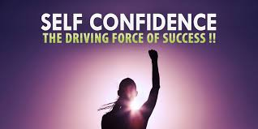

Image Source: publistagram.com

But, why is it so important to have faith in yourself?

In general terms, it provides you with an ability to overcome any obstacle that comes your way. It is a belief that no matter what happens, you will achieve your goals. Even if, due to some unavoidable circumstances you weren’t successful, it gives you enough motivation to stand up and fight back.

**How do you know that you are not self-confident?**

* You always keep your body language in check, the way you look and present yourself.
* Your behaviour is influenced by what other people advise.
* You cover your mistakes before anyone else can know about it.
* You fear of failure and avoid taking risks shows your lack of faith in yourself.

**Need Some Personalised Tips? Follow Me Through the End:**

**1. Believe in Your Instincts, Your Ability to Achieve What You Desire**

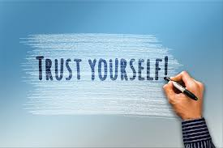

This is a crucial step towards self-confidence.

There is no harm to keep a check on yourself or be presentable. It always boosts your confidence but never be dependent on the outlook. Rather focus on your work. **Quality always surpasses quantity**.

**2. Stop Comparing Yourself**



Comparisons build negative emotions. It starts at home. We have heard a lot about “*Sharmaji ka ladka*”. Yes, we know that he can do anything but, please spare us.

Do you ever feel discouraged when you see your peers’ happy pictures on social media enjoying their life?

Don’t ever get affected by social media. Most of the reality is hidden behind the filter and edited to show just the happy phase of their life.

Every person has a unique ability and quality, no one can be compared to the other. But when you compare yourself with the success and possessions of others, you will only end up experiencing envy and it will not allow you to move forward.

Instead of comparing or being envious, try to think what is it that can help you reach that position. Learn from it rather than feeling miserable.

**3. Face Every Challenge**

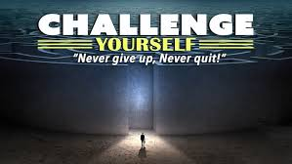

You cannot climb the Mt Everest at one go. People who did climb the Mt Everest must have faced many challenges on their way but that didn’t stop them. If they had stopped in-between, do you think we ever had the first person to climb the highest mountain? Likewise, challenges are there to test your determination. Even if you fail at it once, it should not deviate you from reaching your goals.

Sometimes second chances are better than the first. You are not starting from scratch but knowing well enough to not repeat those mistakes. It helps you in identifying your strength and weaknesses so that you can work on it and have better results next time.

**4. Focus on Positive Things (specifically on yourself)**



There will be times when you feel that you are surrounded by negativity and you are letting yourself go deeper into depression. That’s not a good sign as if you are letting negativity hover over you. But if you remain positive and think about what went wrong and how can you make it right, you can start over anytime.

You know yourself much better than anyone else. Always remember and speak to yourself, *“I can do it”.* Your past achievements are proof of the fact that you can do anything if you have the will to do it.

**Some Final Words of Motivation**

**Self-Confidence is nothing but taking control of your belief and capability.**

You must be thinking that you cannot gain confidence overnight, right?

It’s a continuous process and for that, you have to work.

Even a confident person also sometimes doubt their abilities. You need to make an action plan starting from small steps to long-term plans to build self-confidence and self-esteem.

**Follow these steps:**

* Be assertive in your goals.
* Set short-term challenges.
* Improve your weak areas.
* Change your lifestyle.
* Fill up your mind with [positive thoughts and attitude](https://www.briantracy.com/blog/personal-success/be-the-best-you-7-keys-to-a-positive-personality/).
* Surround yourself with confident people who encourage you.

|  |
| --- |
| **Tip**: Take a [short quiz](https://www.mindtools.com/pages/article/newTCS_84.htm) to find out how self-confident you are and follow these tips to build self-confidence that never shakes before anyone or anything. |